[5 safes of data management](https://uwelibraryresearch.wordpress.com/2017/09/13/5-safes-of-data-management/)

5 Safes is a framework for handling access and re-use requests for confidential or sensitive data. The framework demonstrates best practice for allowing confidential data to be used, without sacrificing the privacy of the individuals represented in the data.

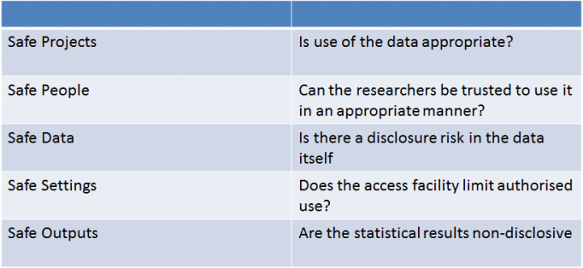

The framework was developed by Felix Ritchie, who gave an [overview of its use](http://bit.ly/2qneoXM) at one of the Open Research Seminars from earlier this year. The 5 safes are pretty self-explanatory:

* Safe projects – use of the data should only be for genuine projects for which it is suitable
* Safe people – the data should only be used by trusted researchers who will use the data appropriately
* Safe data – the data should be de-identified as much as possible
* Safe settings – the data should be stored securely, with limited access
* Safe outputs – the data used in any outputs must not breach confidentiality

The framework is used by the UK Data Service, who have written a [blog post](http://blog.ukdataservice.ac.uk/access-to-sensitive-data-for-research-the-5-safes/) and produced a [four-minute video](https://www.youtube.com/embed/Mln9T52mwj0) about how they use the 5 safes to give access to secure data.

https://uwelibraryresearch.wordpress.com/2017/09/13/5-safes-of-data-management/